

GRM TETTEY’S GROUP
EFFICIENCY CREACTION IN MEDICAL RECORDS AND PATIENT MANAGEMENT

DSW2B | 7 NOVEMBER 2022

GROUP MEMBERS
- GARY TETTEY – 217039298
- ZIZILE EZONA MBANGI- 2210061777
- OLWETHU ASANDE MFEKAYI- 221056377

PROBLEM STATEMENT
PROBLEM DEFINATION
Social Issue identified:
Clinic care facilities appear to be under strain as many people have to join queues in order to get their files they sometimes spend 30 minutes to an hour there waiting before they even get to see the doctor or take your treatment it is far worse when they say they can't find your file it's understandable as there are many files to go through it becomes more tiring even for the nurses.
STATISTICAL FACTS
T I T L E : Luthuli, L.P., 2017. Medical records management practices in public and private hospitals in Umhlathuze Area, South Africa (Doctoral dissertation, University of Zululand). •
From
https://scholar.google.com/scholar?hl=en&as_sdt=0%2C5&q=medical+record+storage+for+low+income+areas+south+africa&btnG=#
https://scholar.google.com/scholar?hl=en&as_sdt=0%2C5&q=medical+record+storage+for+low+income+areas+south+africa&btnG=#d=gs_cit&t=1663774657355&u=%2Fscholar%3Fq%3Dinfo%3ANmfsMBt2fJMJ%3Ascholar.google.com%2F%26output%3Dcite%26scirp%3D0%26hl%3Den

PROBLEM STATEMENT EXAMPLE
https://www.qminder.com/blog/queue-management/wait-times-healthcare/
According to Kirill Tšernov Putting U in Queue at Qminder, There are also some negative financial consequences to mismanaging wait times in hospitals. Quite simply, patients don’t want to deal with hospitals that don’t respect their time. 30% of patients experiencing long wait times leave before seeing the doctor, and 20% change their healthcare providers altogether. Following that, when patients don’t show up for their appointments, the financial consequences continue. To compensate for no-shows, some clinics and hospitals decide to double-book patient appointments — meaning that they give two patients the same time slot for an appointment. Overbooking (adding more visits per day) and double-booking can lessen the impact of no-shows, but these practices are looked down at by medical experts as they also lead to patient backlogs, overworking your staff, and the decrease in quality of care.
SOLUTION STATEMENT EXAMPLE
The solution we are building for the problem defined is a mobile application that will be used in clinics to archive people's files will reduce the amount of time they spend waiting for nurses to find their files and long lines. For the standard users interface, the users will be urged to log in with their credentials if they already have an account and if they don’t they will be required to sign up. Upon logging in, the users will be directed to the homepage, where they will be able to see the files, make appointment and doctor availability. When they click under each categorised tab, they will be able to enter their hospitals and all programmes in that they can access will be shown. The patient will be able to click on the specific hospital and see the doctor details, such as the working hours.
For the Hospital user interface, the doctors users will also be urged to log in with their credentials if they have an account already and register if they don’t. Upon logging in, they will be directed to the homepage where they will be able to see their hospital details if they have already entered them, if not they can do so under the admin tab which will consist of fields they need to fill in about their profession and thereafter be able to save them and also be able to update them.

PROJECT SOLUTION OBJECTIVE
Our Project's goal is to bring solution to an ongoing problem of people having to wait in long queues for their medical records.
People are going to be able to download their files through MED.Tech website. Admin are also going to be able to check if a particular doctor is booked or not to avoid over booking one doctor.
Additionally, it will be simpler for patients when they relocate because they won't have to go ask for their file records instead, they can ask their previous doctors to give the new hospital permission to view their file through the system.

SYSYEM ARCHITECTURE
USE CASE DIAGRAM
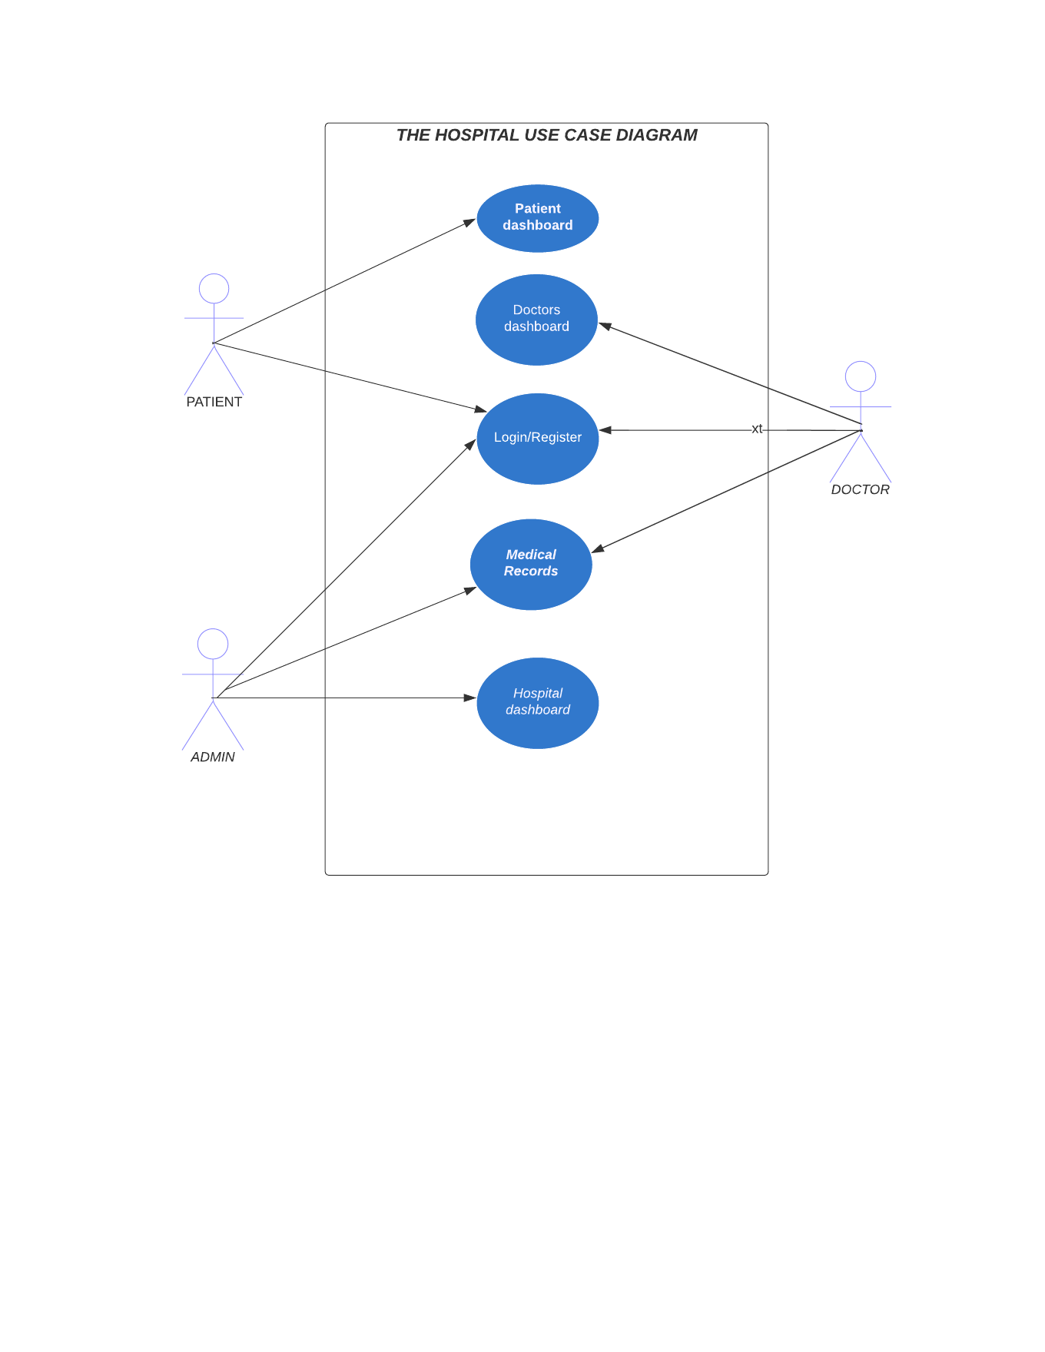
UML DIAGRAM
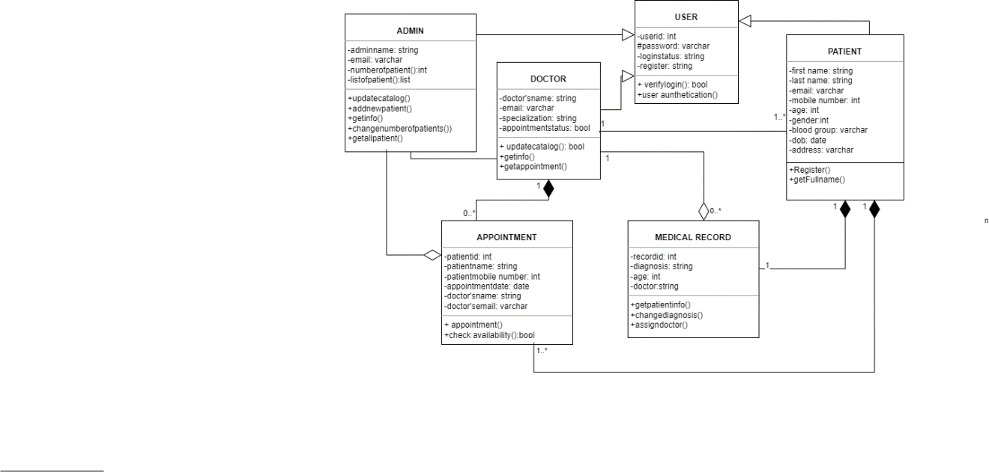

SCREEN MOCKUPS/LAYOUT
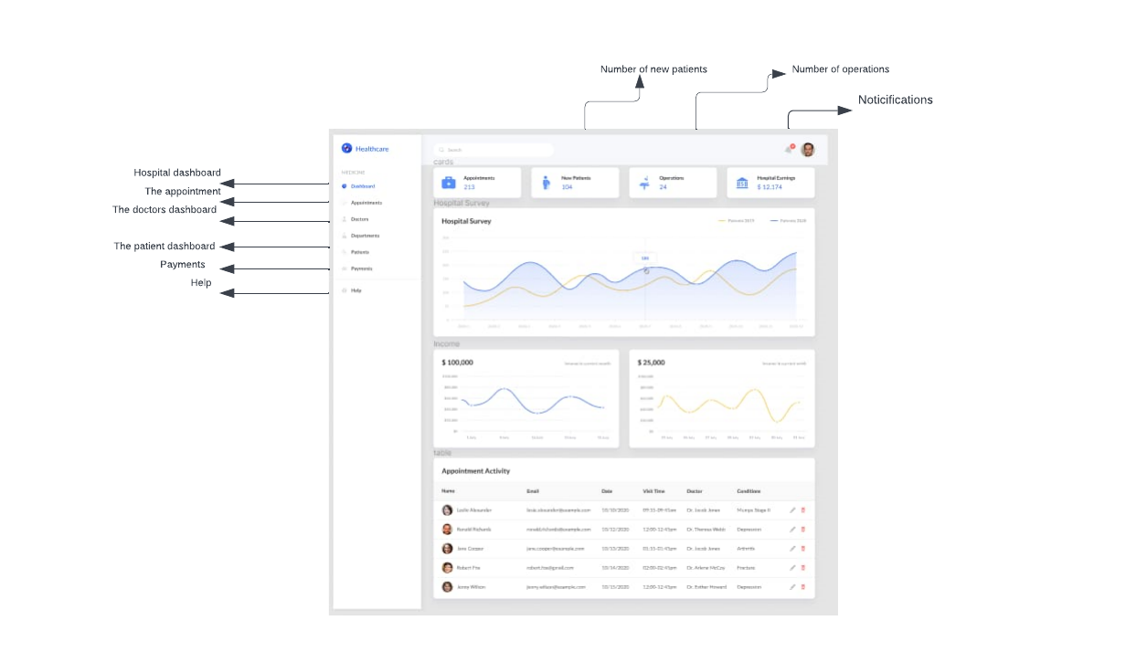
This is a hospital dashboard where administrators can log in to register new patients, access doctor appointments, and help patients pay their bills. The administrator checks the availability of doctors before booking new patients. Admins can also view the entire list of doctors and receive all important notifications.
Patients can click on the patient dashboard to log in and see upcoming appointments and the name of the doctor assigned to that appointment. You can also download medical records.
Doctors can click on the Doctors Dashboard to log in and view appointments, download patient records, view personal profiles, general reports, and past visit history. They can also write feedback on Medical record of the patient
Click on the notification to see everything happening in the hospital. You can see all new patients and operations.
API USED
REFERENCES

